Linux LOGS

Linux maintains various log files to help administrators track system activities and troubleshoot issues. Here are some common log files along with simple explanations:

**/var/log/**

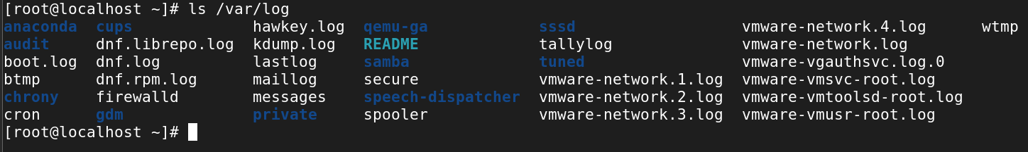

**1./var/log/messages**

Explanation: This is the primary log file that records a wide range of system events, including boot messages, service start up and shutdown, and general system errors.

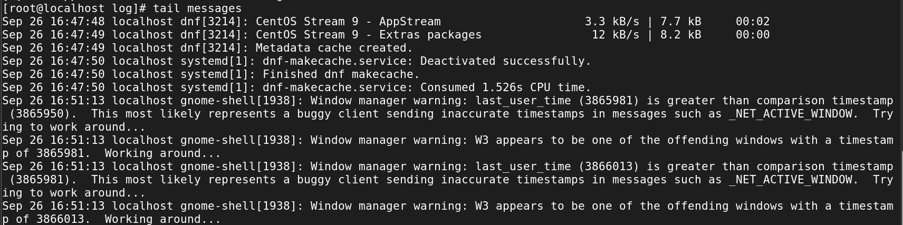

**2./var/log/secure**

Explanation: This log file keeps track of security-related events, such as authentication attempts (successful and failed), sudo usage, and other security-related messages.

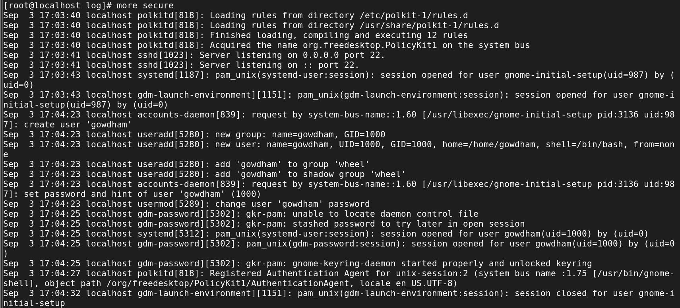

**Authentication failure**

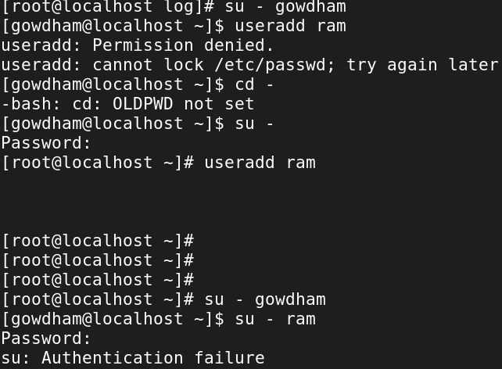

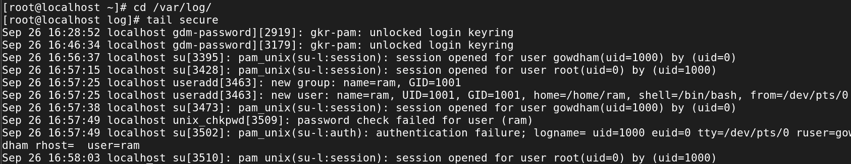**3./var/log/cron**

Explanation: Logs generated by the cron daemon, which schedules and executes periodic tasks, are recorded here.

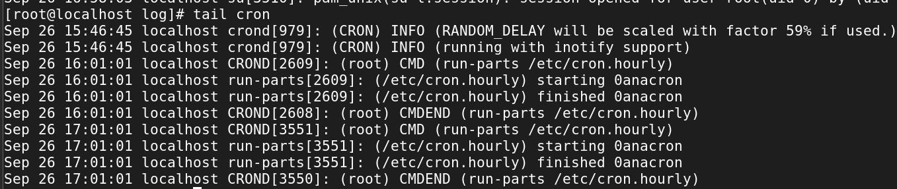

**4./var/log/dmesg**

Explanation: Contains kernel ring buffer messages, which are low-level system messages useful for diagnosing hardware and driver issues.

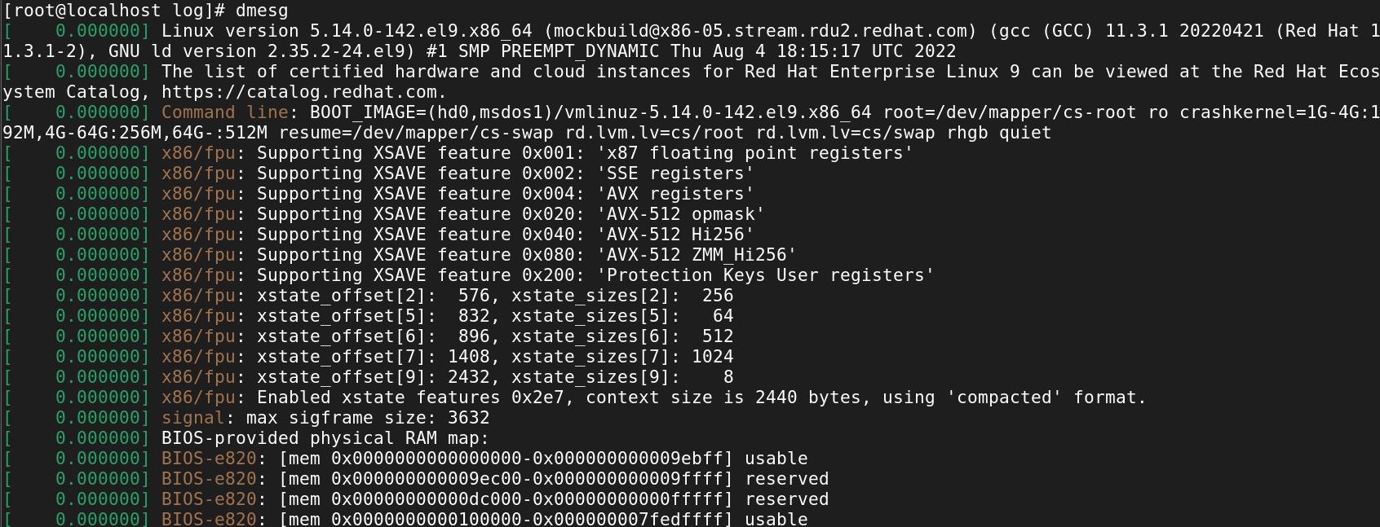

**5. /var/log/boot.log**

Explanation: Captures messages related to system boot processes, including the startup of various services.

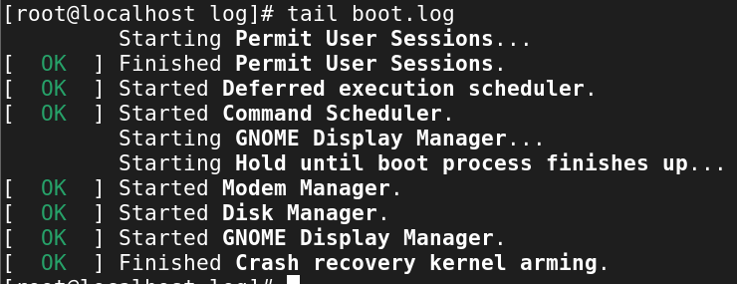

**6. /var/log/dnf.log**

Explanation: Tracks package installation, updates, and removal activities performed using the YUM package manager.

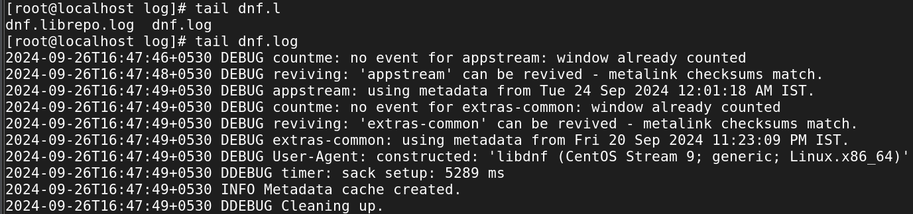

**7. /var/log/audit/audit.log**

Explanation: Stores audit logs generated by the Linux Auditing System, which is used for security auditing and monitoring.

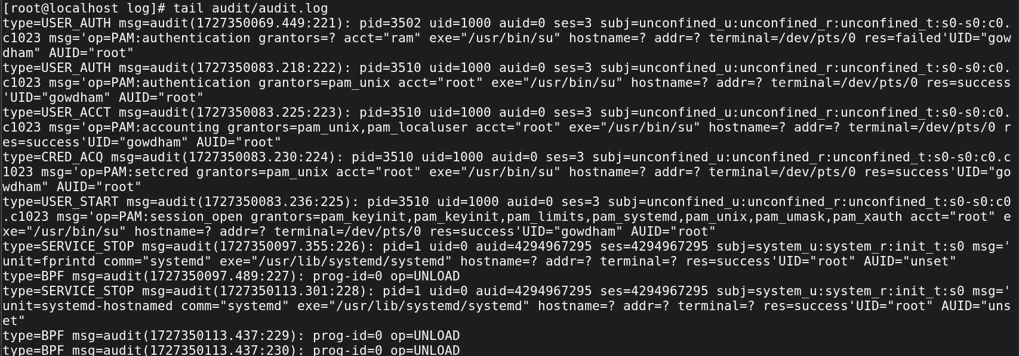

8. /var/log/httpd/

Explanation: Directory containing log files for the Apache web server, including access logs and error logs.

9. /var/log/maillog

Explanation: Logs related to the mail server, including messages sent and received, errors, and other mail server activities.

10. /var/log/lastlog

Explanation: Records the last login time of each user. It is not a regular text file but can be viewed using the lastlog command.

11. /var/log/btmp

Explanation: Records failed login attempts. Like lastlog, this is a binary file and can be viewed using the lastb command.

12. /var/log/wtmp

Explanation: Records login and logout events. This binary file can be viewed using the last command.